Input Data Representation
The input data are separated into two separate files for rows and columns, CHROWS and CHCOLS respectively. In both files, each line corresponds to one input case. The representation is chosen so that the spatial distribution of input cases across the crossbar circuit can be more easily observed. However, the representation can be written minimally using 20 bits (instead of 30) by log₂ conversion.
- Each line in CHROWS has 20 bits corresponding to 20 rows in the crossbar. For each input case (each line) the 5 selected rows are marked as 1.

“00000000000000011111”

- Each line CHCOLS has 10 bits corresponding to 10 columns in the3 crossbar. For each input case (each line) the 2 selected columns are marked as 1.

“0000101000”

- The leading numbers before the ‘comma’ sign are handling identifiers and should be removed from the input cases.

0,”0000000011”

- The full input in each case (line) can be represented by concatenating corresponding lines in CHROWS and CHCOLS.

“000000000000110011010010100000”

- Overall, the input-output relationship can be represented in the following form.

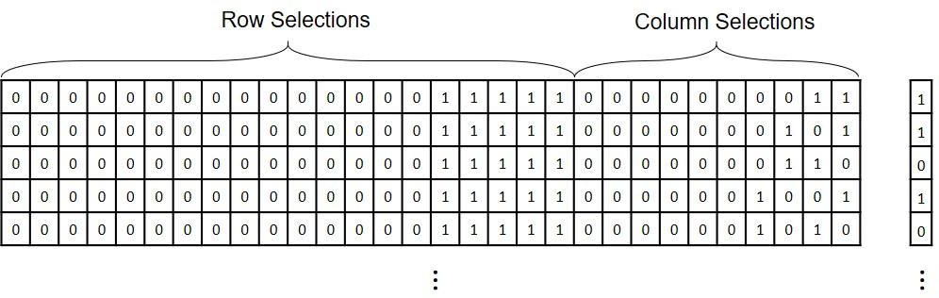

Output Data Representation
- The output bits in this experiment can be attained from the sign of current differential (column 3 in the current files).
Negative sign: 0
Positive sign: 1
- The connection file ("Cons.txt") contains information regarding the order of current readouts (the order was randomly changed with respect to the column numbers between two SMUs in the experimental setup to offset the margin difference between the two SMUs). The effect of connection swapping on the output current differential can be removed by the following rule (a logical NOT operation):
If Cons bit = 0 -> The current differential sign (column 3) is correct
if Cons bit = 1 -> The current differential sign (column 3) should be inverted

Output Bits at Elevated Temperatures
The data in represented in MATLAB arrays in the following format:
- “INPUTS.mat” contains the input cases, separated in rows (R: 4800×20) and columns (C: 4800×10). Corresponding to the same input format as described before.

- Output files contain two arrays of responses at two different temperatures (room temperature and 90 C) to the input cases at the designated bias

Example: “600mv.mat” contains two arrays. One for responses at room temperature (“V600.mat”) and one for responses at 90C (“V600at90C.mat”)

